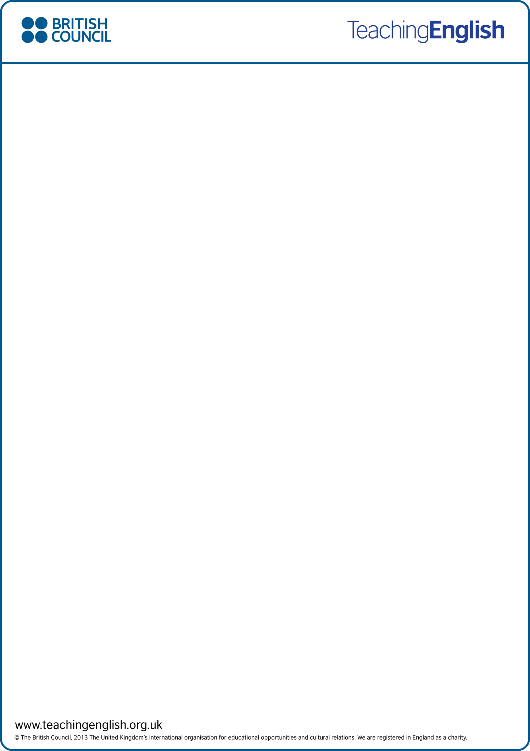
SPEAKING AND READING

Group discussion
Where do you get your news? Which sources do you use?
Google
Media

What do you think about this sentence? ‘It must be true because I read it on the internet.’
Everything on the internet isn’t true

What do you understand by ‘fake news’? Brainstorm some keywords you associate with it.
fabricated or inaccurate news, Misinformation, Disinformation, rumours, Gossips, Bum Steer

Skim read the two websites. Complete the table.
Go to these links and read them quickly. Make brief notes about the tree and the octopus.

https://zapatopi.net/treeoctopus/ https://www.atlasobscura.com/places/octopus-tree-of-oregon

 | Habitat | Characteristics | History
Tree Octopus | in the temperate rainforests of the Olympic Peninsula on the west coast of North America. | These solitary cephalopods reach an average size (measured from arm-tip to mantle-tip,) of 30-33 cm. Unlike most other cephalopods, tree octopuses are amphibious, spending only their early life and the period of their mating season in their ancestral aquatic environment. | The octopus has been endangered because the fashion industry began to kill it in large numbers and sell it to the rich in the form of hat ornaments.
Octopus Tree | Pacific nirthwest coast of the USA.

Check the validity of the two websites using the FIVE Ws.
Which site is fake? How do you know it’s fake?

Find one of these recent fake news stories. Create an informative meme or post to warn your friends about it.

A weird cat with two legs was captured by Google Street View.

Japan has the best fireworks in the world – the fireworks are moons and stars.

The world’s tallest teenager is 6ft 11in (210.82cm) and towers over her teacher.
A 79-year-old woman called Abigail wants to give you $5.7 million to distribute to charity

Kentucky Fried Chicken is giving three free chicken buckets to everyone as a way of celebrating the company's 67th anniversary

The actor Peter Dinklage (who plays the character Tyrion Lannister in Game of Thrones) is dead.

www.teachingenglish.org.uk
© The British Council, 2019 The United Kingdom’s international organisation for educational opportunities and cultural relations. We are registered in England as a charity.

THE FIVE W-QUESTIONS FOR SPOTTING FAKE WEBSITES

WHERE does the information come from?
Look at the URL. Does it look familiar or credible?
TIPS
Websites with these URLs are usually legitimate: .com, .org, .net, .edu, .gov
Fake websites often have URLs that end with: lo, .com.co. Alternatively, fake URLs are incomplete. Fake websites have similar names to authentic sites, e.g. Sky Newz (instead of Sky News).

WHEN was the post put online?
What’s the date on the post? Is the date real? Is the post recent?
TIP
Fake news is often posted on dates which don’t exist (e.g. 30 February) or on 1 April (April Fool’s Day). Always check the date. Sometimes the news was posted years ago but is still being circulated as ‘news’.

WHO created the information?
Who wrote the article? Who took the photo?
TIPS
Real photos should always give the name of the person who took them (or explain where they come from).
Look at photos carefully. Could they have been Photoshopped? Check suspicious photos by doing a reverse Google image search. Other websites may have used the same photo for different news.

WHAT does the post or website look like?
Look at the layout. Is the website well presented and carefully organised? Look at the headline. Is it sensational?
Is there an ‘About Us’ section with contact information? Are sources given for the information? Is the spelling and grammar correct?
TIPS
Genuine websites usually look professional. They usually contain an ‘About Us’ section, contact information, sources and links to more information.
Check the spelling and grammar. Fake websites often contain mistakes in English.

HOW do you know for certain that it’s true?
Check the content again. Does any information seem unlikely? Too good (or too amazing) to be true?
TIPS
Real news stories should appear in several news outlets, not just the one you’re looking at. Cross-check the information with a credible website to see if you can find the same story!

www.teachingenglish.org.uk
© The British Council, 2019 The United Kingdom’s international organisation for educational opportunities and cultural relations. We are registered in England as a charity.

If you’re still not sure, check a site that lists hoaxes and fake news. Is the story listed as fake news? Try: https://www.snopes.com/ https://www.hoax-slayer.net/

www.teachingenglish.org.uk
© The British Council, 2019 The United Kingdom’s international organisation for educational opportunities and cultural relations. We are registered in England as a charity.

